SEMESTER TWO
Papers written by Australian Maths Software

YEAR 12
MATHEMATICS SPECIALIST
UNITS 3-4
2017
Section Two
(Calculator–assumed)

Name: _________________________________

Teacher: ________________________________

TIME ALLOWED FOR THIS SECTION

Reading time before commencing work: 10 minutes
Working time for section: 100 minutes

MATERIAL REQUIRED / RECOMMENDED FOR THIS SECTION

To be provided by the candidate
Standard items: pens, pencils, pencil sharpener, highlighter, eraser, ruler.
Special items: drawing instruments, templates, notes on up to two unfolded sheet of A4 paper, and up to three calculators approved for use in the WACE examinations.

IMPORTANT NOTE TO CANDIDATES
No other items may be taken into the examination room. It is your responsibility to ensure that you do not have any unauthorised notes or other items of a non–personal nature in the examination room. If you have any unauthorised material with you, hand it to the supervisor before reading any further.

To be provided by the supervisor
Question/answer booklet for Section Two.
Formula sheet retained from Section One.
Structure of this examination

 | Number of questions available | Number of questions to be answered | Working time (minutes) | Marks available | Percentage of exam
Section One  Calculator—free | 7 | 7 | 50 | 52 | 35
Section Two  Calculator—assumed | 12 | 12 | 100 | 98 | 65
Total marks |  |  |  | 150 | 100

Instructions to candidates

1. The rules for the conduct of this examination are detailed in the Information Handbook. Sitting this examination implies that you agree to abide by these rules.

2. Write your answer in the Question/Answer booklet.

3. You must be careful to confine your responses to the specific questions asked and to
follow any instructions that are specific to a particular question.

4. Spare pages are provided at the end of this booklet. If you need to use them, indicate in the original answer space where the answer is continued i.e. give the page number.

5. Show all your working clearly. Your working should be in sufficient detail to allow your answers to be checked readily and for marks to be awarded for reasoning. Incorrect answers given without supporting reasoning cannot be allocated any marks. For any question or part question worth more than two marks, valid working or justification is required to receive full marks. If you repeat an answer to any question, ensure that you cancel the answer you do not wish to have marked.

6. It is recommended that you do not use pencil, except in diagrams.

7. The Formula Sheet is not to be handed in with your Question/Answer booklet.

8. (6 marks)
(a) Sketch the shaded region defined by
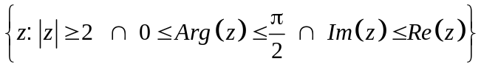 (3)

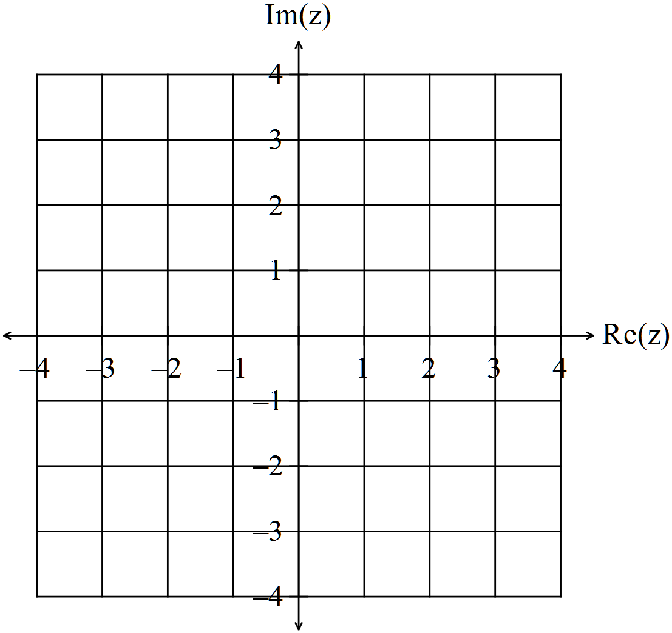

(b) (i) Plot the 6 roots of unity on the set of axes below. (1)
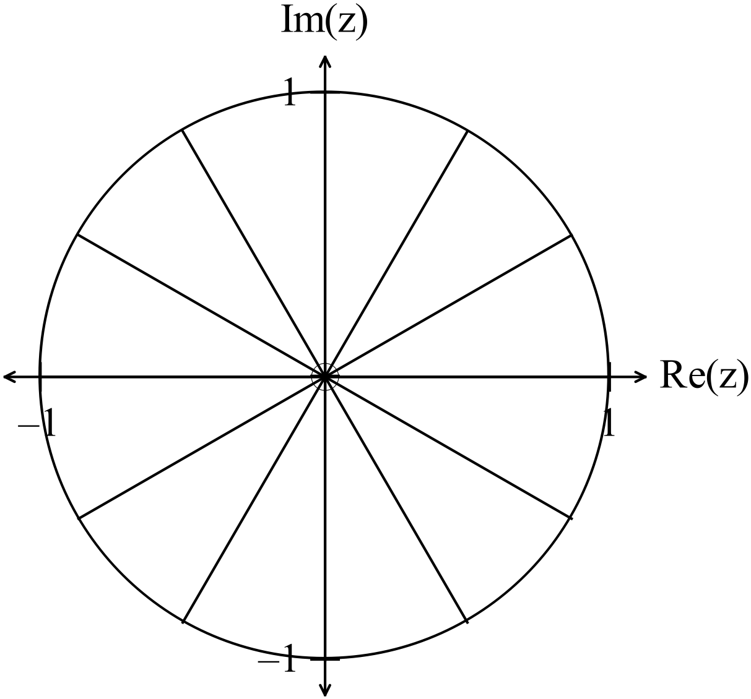

(ii) Write down the 6 roots of unity. (2)

9. (3 marks)
A particle moves in a straight line so that 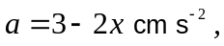 and when
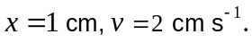
Find the velocity when 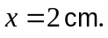
HINT: 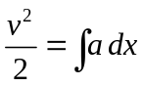 (3)

10. (8 marks)
A conical tank of base radius 5 m and height 12 m is being filled with water at a rate of
1.5 m³ per minute.
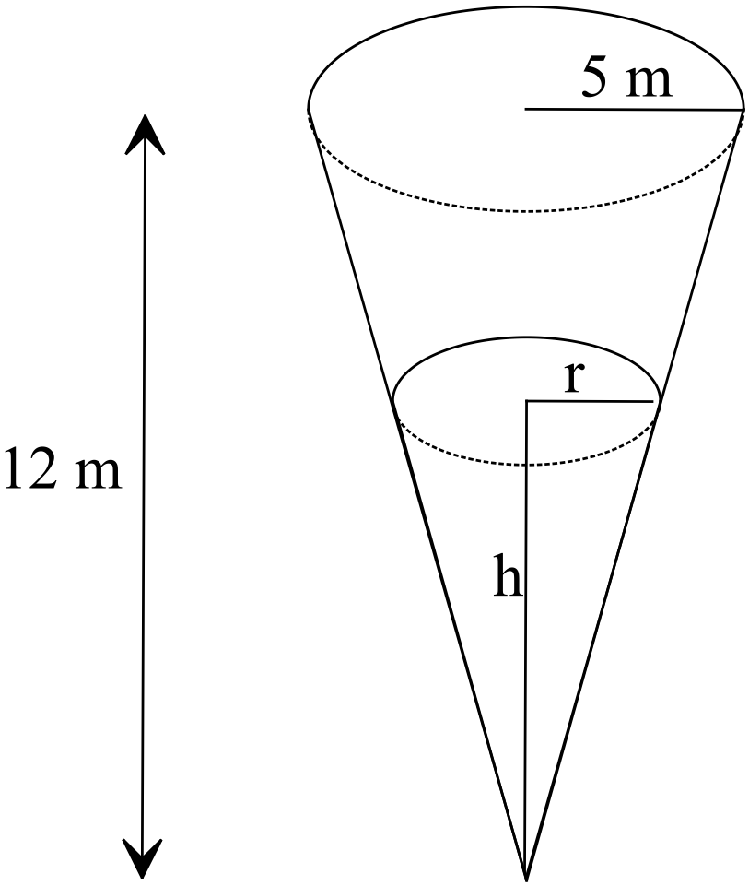
(a) Find the rate at which the height of the water is rising when the water is 2 m
high. (4)

(b) What is the height of the water after 2 minutes? (2)

(c) Find the rate at which the radius is increasing when the height is equal to 2 m.
(2)

11. (16 marks)
(a) (i) Write down the expression for 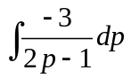. (2)

(ii) Use your calculator to evaluate 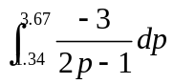 correct to three decimal places.
(2)

(b) Write down the expression for the shaded area between the functions
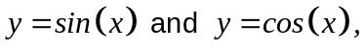 as shown in the diagram below, and calculate
the area correct to three decimal places. (3)

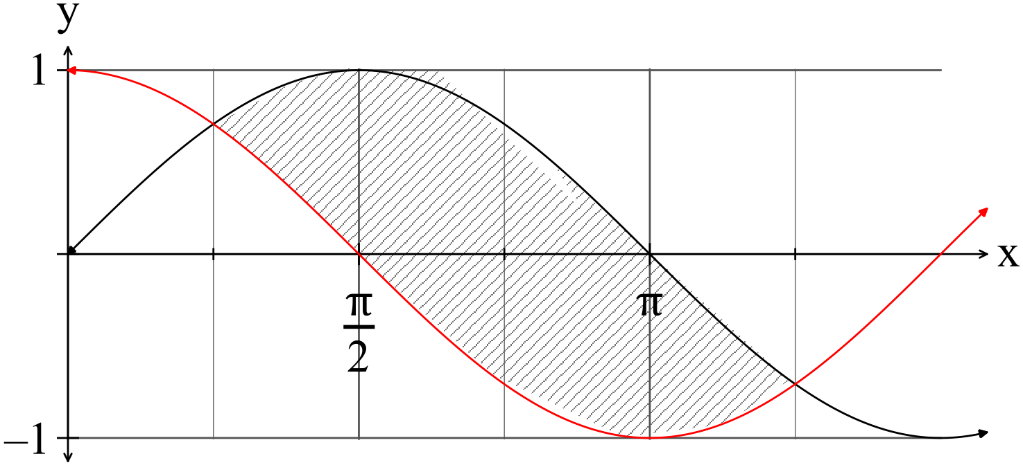

(c) The region define by 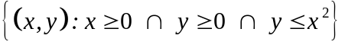 for 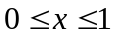 is rotated
about theaxis to generate 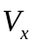and then rotated about the y axis to generate 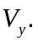

Prove that 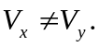 (5)

(d) A vase is generated when the shaded area in the diagram below is rotated
about the y axis. The parabolic segments have equations 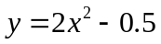 and
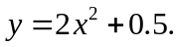
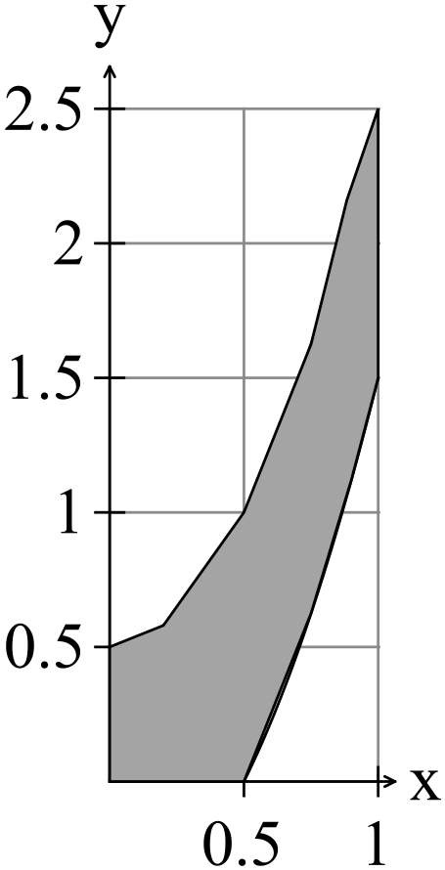
Determine the expression that if evaluated gives the volume of the vase. (4)

12. (3 marks)

For every degree Celsius the temperature increases in a given range, the radius of ball
bearings in an engine increase by 0.01 mm.
If the temperature of the engine increases one degree Celsius (in the given range) and
the ball bearings had a radius of 1.5 cm immediately before the temperature increase,
use a calculus method to determine the corresponding increase in volume of the ball
bearings. (3)

13. (18 marks)
(a) Consider the functions 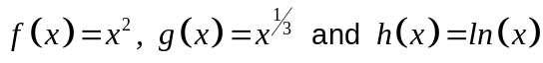.
(i) Find the expression for 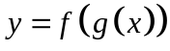 and sketch the relation on the set of
axes below. (3)

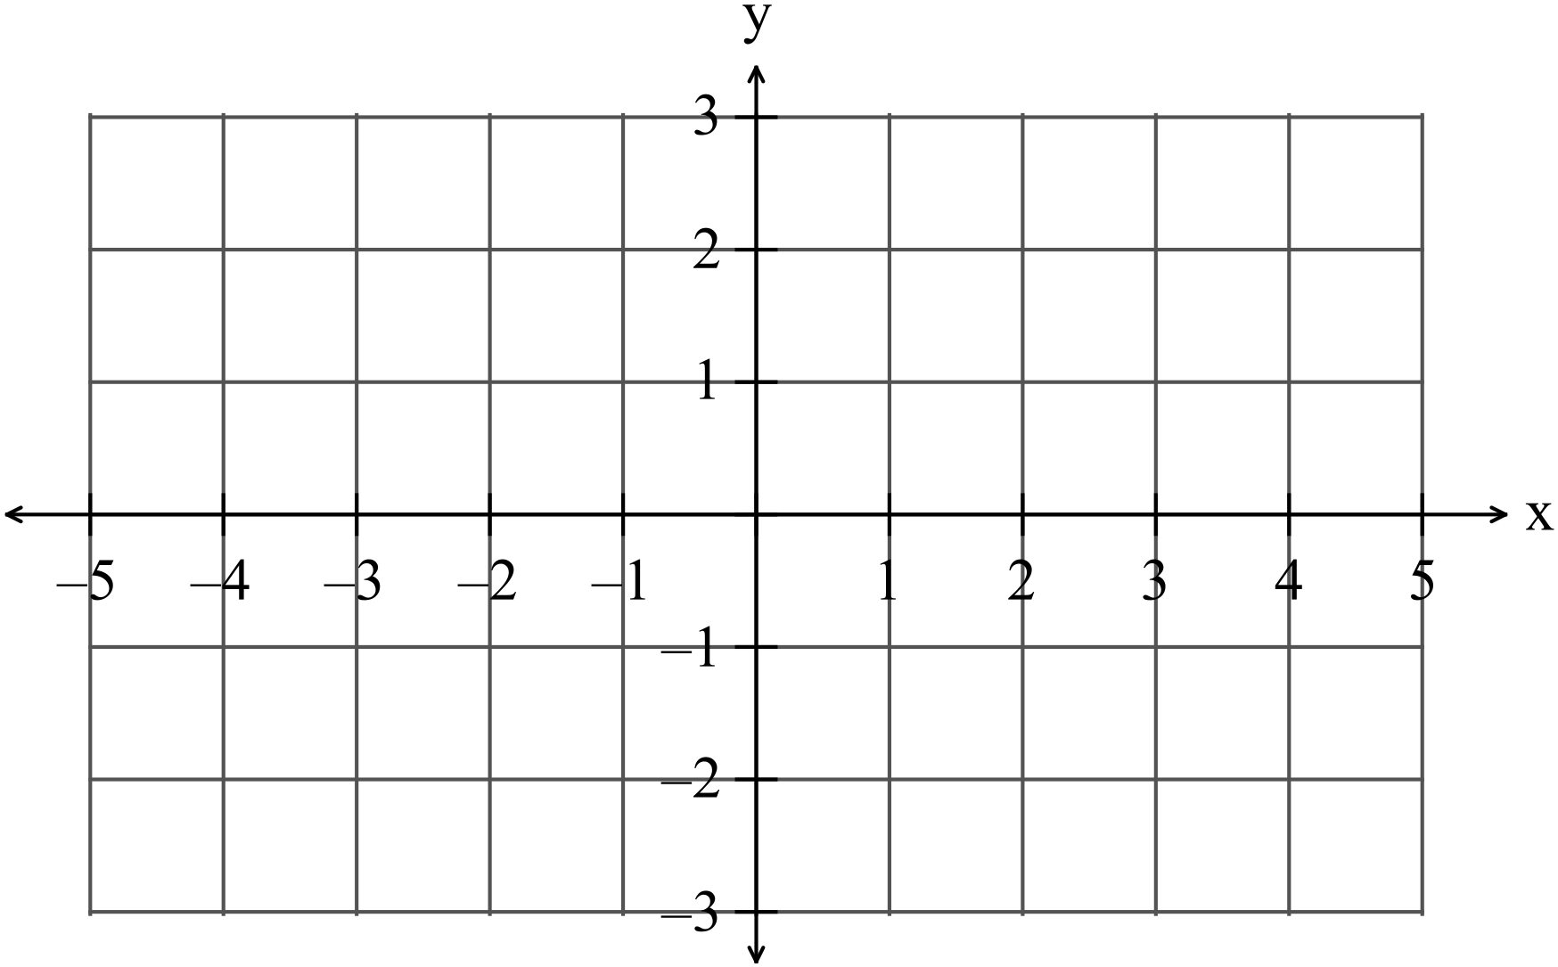

(ii) Determine whether or not the function has an inverse. Explain.
(2)

(iii) Give the largest domain possible such that 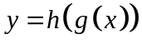exists. (2)

(b) Consider the function 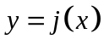graphed below.
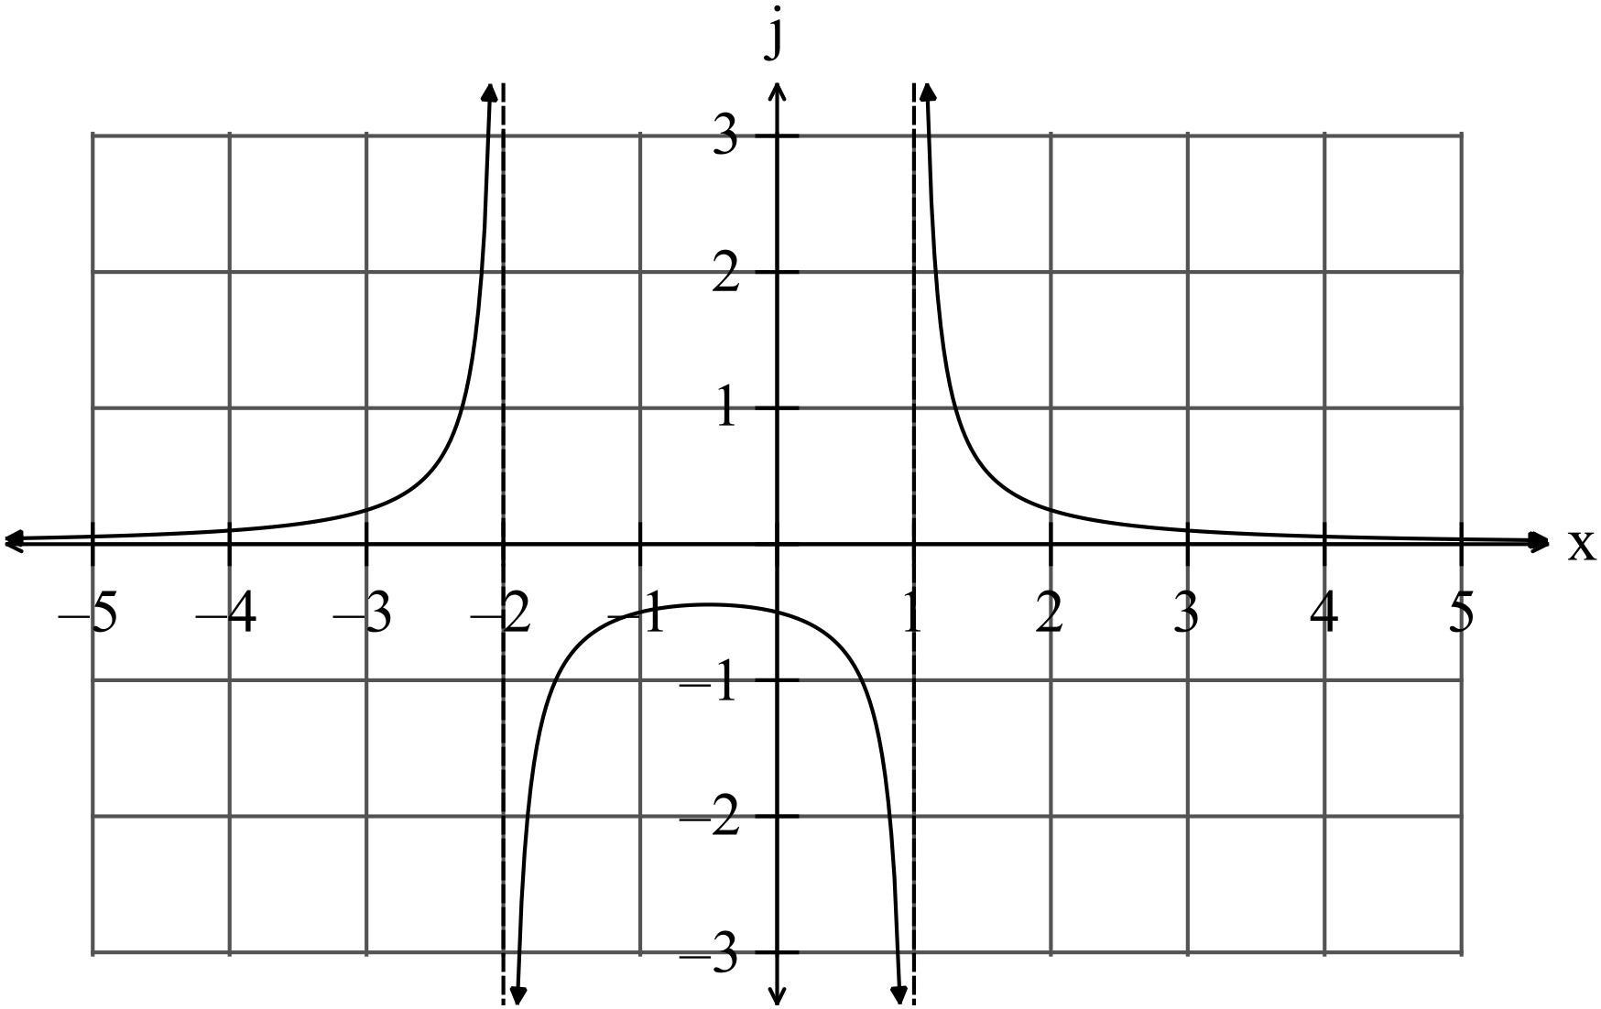

(i) Sketch 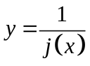 on the set of axes above. (2)

(ii) Hence or otherwise write down the equation of the function. (2)

(iii) Using the graph of as a guide sketch 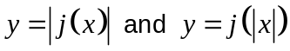
on the two sets of axes below.

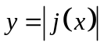 (2)
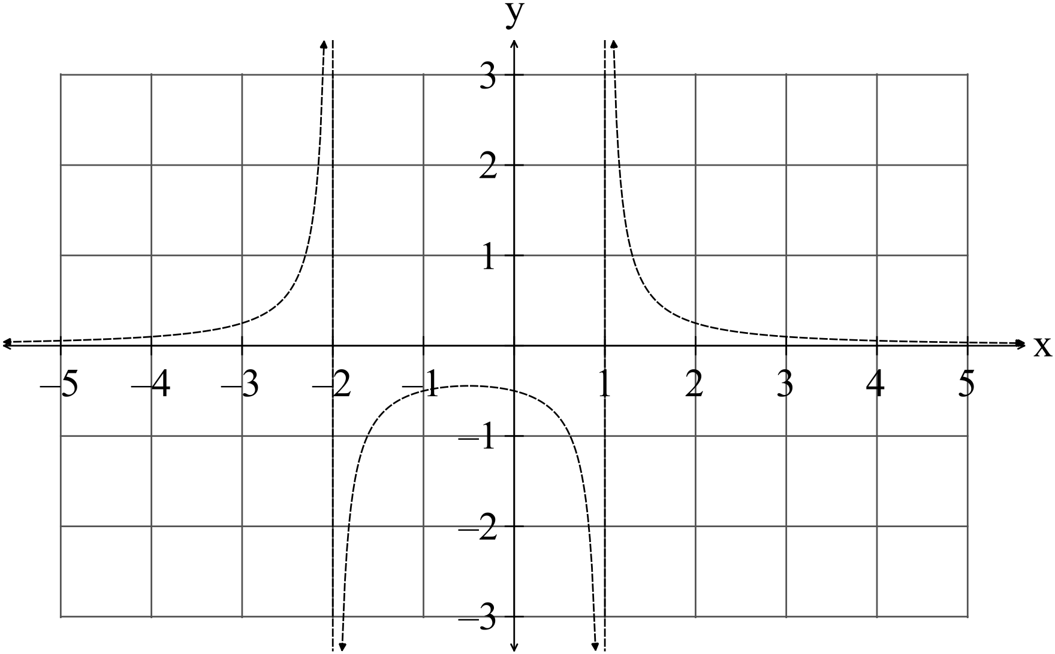

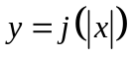 (2)

(c) Find the function 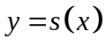 given 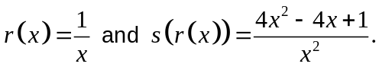 (3)

14. (6 marks)
(a) Given 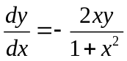 find an expression for in terms of given that (1, 1)
belongs to the curve. (4)

(b) Given the slope field of is shown below, trace the function that
you found in (a) on the diagram below. (2)
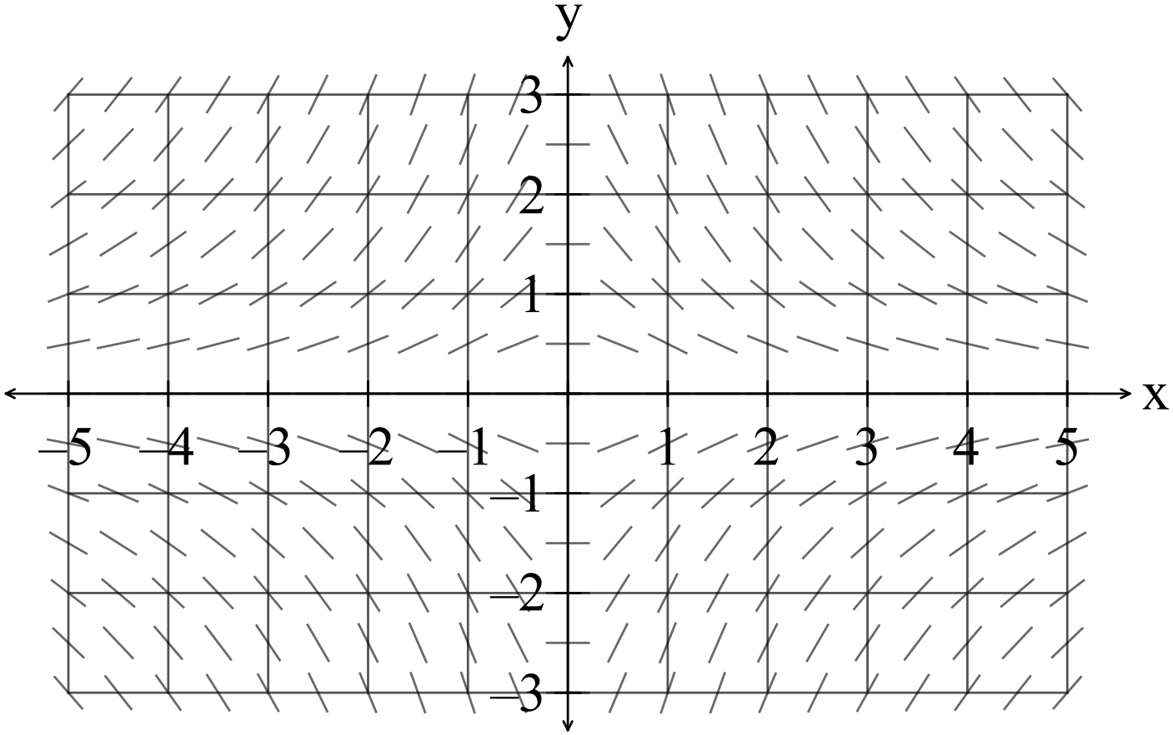

15. (7 marks)

(a) A salmon is swimming upstream at Hydra in Alaska.
The salmon is at 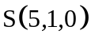and moving with a velocity of 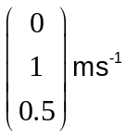 against
the current.

A bear perched on a rock in the water at B(6, 3, 0.5) can reach a distance of
one metre safely and is ready to have the salmon for lunch.

What is the minimum distance of the salmon from the bear? (3)

(b) Another salmon is at 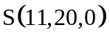and moving with a velocity 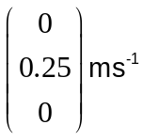
against the current. An eagle at 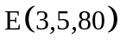spies the salmon and swoops with a
velocity of 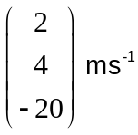.
Does the eagle catch the salmon? (4)

16. (6 marks)

(a) Solve the following system of linear equations.
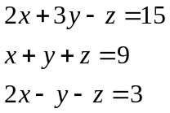
(4)

(b) Determine whether the system of equations
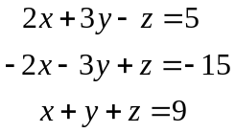
has one solution, no solution or an infinite number of solutions giving your
reasons. (2)

17. (8 marks)

(a) It is required to estimate the height of 17 year old girls in Year 12.
Twenty samples of size 10 are taken from the year 12 population of girls.
The mean of each sample is calculated. The means form a sampling
distribution with a mean 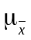 and a standard deviation 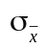.
(i) Describe the shape of the sampling distribution. (2)

(ii) Explain carefully why the estimate required can be found using the mean
of the sampling distribution. (2)

(iii) Comment on and state the reason for the size of the standard deviation of
the sampling distribution compared to to the standard deviation of the
parent population.
(2)

(b) The means of a large set of samples of size 100 have a mean of 20 and a
standard deviation of 1.5.
Find the mean and variance of the parent population. (2)

18. (8 marks)
A biologist wanted to estimate, within a 95% confidence interval, the mean weight of
the male adult quokkas that live near Chandler Road in the North Jarrah Forrest.
From working with quokkas on Rottnest Island he believed the mean weight of
quokkas was normally distributed with a standard deviation of about 500 grams.

(a) A random sample of 16 adult male quokkas from Chandler Road were weighed
and found to have a mean weight of 4.2 kg.

Determine the 95% confidence interval and explain your findings. (4)

(b) The biologist wanted to re-test the mean weight of the Chandler Road adult,
male quokkas so he could be 99% sure the mean weight was within 0.2
kilograms of the true mean.

What size sample would the biologist need? (4)

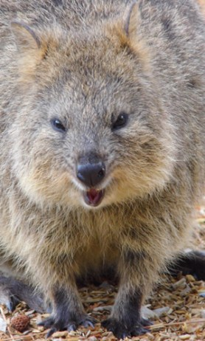 http://theanimalfacts.com/mammals/quokka/
19. (9 marks)
(a) Given one example of the logistic function is 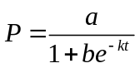find an expression
for 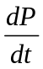and explain why  is always increasing for 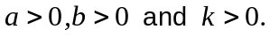 (3)

(b) The Australian Wildlife Conservatory released 50 numbats into a fenced refuge
for protection from foxes and cats.
After 5 years the numbat population was 215. The A.W.C. thought that
the environment would be able to support no more than 3000 numbats.
(i) Given a model for the numbat population is where t is in years,
find the values of 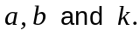 (5)

(ii) Use the model to estimate the numbat population after 15 years. (1)

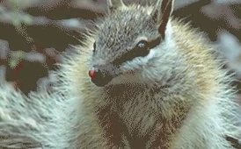

END OF SECTION TWO
Extra page for working if necessary

Extra page for working if necessary

